The Montana Bird Conservation Partnership, (montanabirds.org) started the “Curlew Initiative” to help conserve habitat for this and other grassland species across the state. For a variety of reasons, the Flathead Indian Reservation/Mission Valley and surrounding grasslands has been chosen as one of the focal area for these efforts.

We would like to know more about where Curlews live in western Montana! To fill out a postcard of any sightings of curlews go to **mtaudubon.org and click   
on this curlew** **image**   
(right).

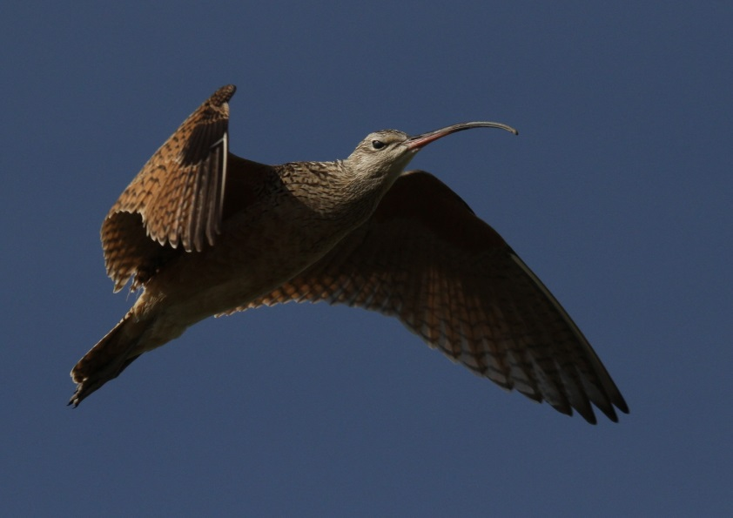

*Bob Martinka, photo*

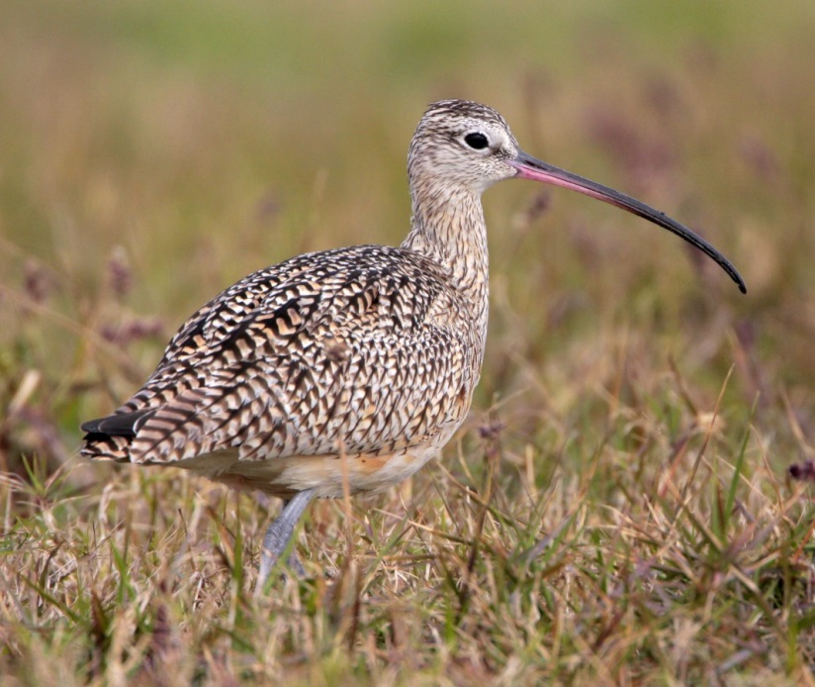

*Greg Lavaty, photo*

# How You Can Help

First, we are very interested in where we find Long-billed Curlews in the Mission Valley. Please keep your eyes open and ears tuned! If you find Curlews, please fill out the accompanying postcard (see back of this brochure for both postcard and contact information).

Grasslands provide critical habitat to many species of birds and other wildlife. Conservation practices that promote healthy grassland habitats are beneficial to both livestock and many species of wildlife. Specifically, curlew habitat can be improved by implementing appropriate grazing management, avoiding conversion of grasslands, establishing native grasses and forbs, reducing the use of pesticides to maintain insects and other valuable food resource , and minimizing disturbance during the breeding period (~ April 15–July 15 in the Mission Valley area).

Every land owner has different needs and conditions. We encourage you to **contact your local Natural Resources Conservation Office** for help designing specific **Best Management Practices** that work for you, your lands, the Curlew, and other local wildlife.

**Compatible NRCS Conservation Practices:**

**Prescribed Grazing** (528); Conservation Cover (327); Prescribed Burning (338); Forage and Biomass Planting (512); Range Planting (550); Restoration of Declining Habitats (643); Upland Wildlife Habitat Management (645); Wetland Wildlife Habitat Management (644); Wetland Creation (658); Wetland Restoration (657); supplemental practices include Fence (382) and water developments for livestock.

**Financial Assistance Programs:**Private land trusts (Five Valleys Land Trust, The   
 Nature Conservancy, Montana Land Reliance, etc.)

Conservation Reserve Program (CRP)

Grassland Reserve Program (GRP)

Conservation Stewardship Program (CSP) Environmental Quality Incentives Program (EQIP)

Wetland Reserve Program (WRP)

**Financial Assistance Programs**

Conservation Reserve Program (CRP)

Grassland Reserve Program (GRP)

Conservation Stewardship Program (CSP)Environmental Quality Incentives Program (EQIP)

Wetland Reserve Program (WRP)

**Learn more about this bird and grassland conservation opportunities**

**The Long-billed Curlew**  
in the Mission Valley &

Surrounding Grassland Areas



Via this webpage, you can   
print and fill out a postcard, request more postcards, or fill out the information online.

**For more information contact:**

Amy Cilimburg at Montana Audubon

406.465.1141; [amy@mtaudubon.org](mailto:amy@mtaudubon.org)

or

Janene Lichtenberg at Salish Kootenai College  
406.275.4896; [janene_lichtenberg@skc.edu](mailto:janene_lichtenberg@skc.edu)

or

Kari Smith at CSKT Wildlife Management

406.883.2888 ext.7217; [kari.smith@cskt.org](mailto:kari.smith@cskt.org)







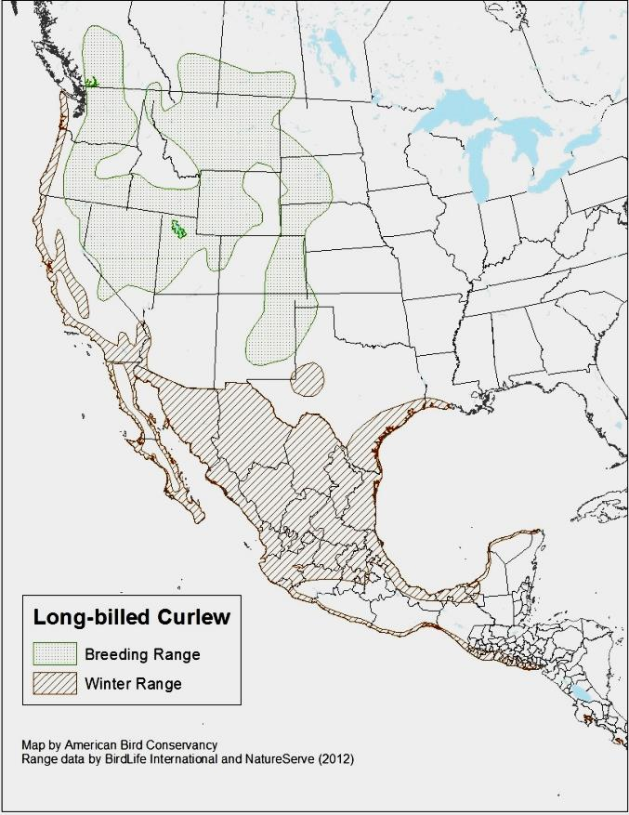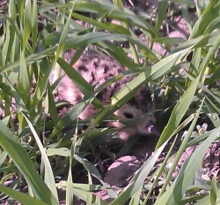

# How to recognize a Long-billed Curlew

The Curlew is about the size of a duck, 23” tall, with a 35” wingspan. It has buffy, cinnamon colored plumage and blurred, brownish streaks in the neck, fading into the belly.

It is best identified by its long, bluish legs and extremely long bill that curves downward. The bill is orange at the base and darker towards the tip.

It makes a loud, whistled “curr-leeeee” sound, which is heard frequently early in the nesting season.

In this region of western Montana, it might be confused   
with a Wilson’s Snipe, which is considerably smaller, 10.5”, and with a long, straight bill (*below, left; Curlew, right*).

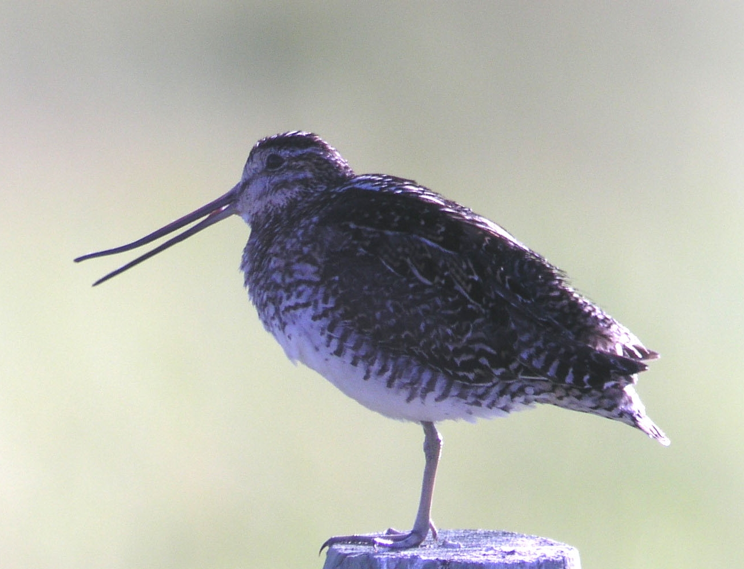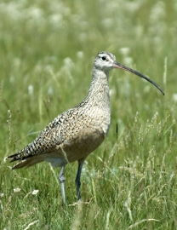

# Description of Curlew Habitat and Biology

* Breeding and summer habitat consists of expansive, open, level to gently sloping or rolling grasslands with short vegetation such as shortgrass or recently grazed mixed-grass prairie.
* Large blocks of native grassland (120 acres or more) are preferred.
* Will forage in hayland, cropland, fallow, or stubble fields and, in the Mission Valley, sometimes nests in these habitats. Also forages in wetlands, mudflats, and shorelines.
* Nests often located relatively close to a water source.
* Typically avoids trees and large shrubs when nesting.
* Nests on the ground, usually near an object like a dirt mound or cow patty.
* Nest is approximately 8” across by 3” deep and lined with grasses, pebbles,   
  bark, or dry dung.
* It lays beige or light green eggs with brown or purple markings.
* Eggs about 2½” by 2” in size and there are usually 4 per nest.
* Chicks born with eyes open, covered in down, and able to leave   
  the nest within hours of hatching.
* Diet of insects, worms, marine and freshwater invertebrates.

*Byron Crow, photo*

*Mike Parr, photo*

# Long-billed Curlew

*Numenius americanus*

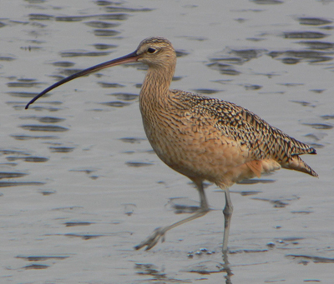

The Long-billed Curlew, a bird of grasslands and prairies, is actually North America’s largest “shorebird”. Like many other grassland species, numbers have declined across its range during the past few decades, as suitable nesting and winter habitat has been converted to other uses. In the Mission Valley and surrounding areas it appears we have many curlews, and we are focused on keeping it this way. Good grassland conservation combined with specific agricultural practices can help this bird and many other grassland critters.

The Curlew’s breeding and summer range consists of grasslands from Texas into southwestern Canada. They winter along the Pacific coast from California through Central America. Spring migration to breeding grounds begins in March. Fall migration south to winter grounds begins in late July (see map, *right*).